Undertake effective development to make and trial a prototype.

# Macintosh HD:Users:dit:Desktop:Screen Shot 2014-10-20 at 9.01.24 AM.pngScreen 1 Code:

# Screen Easy Code:

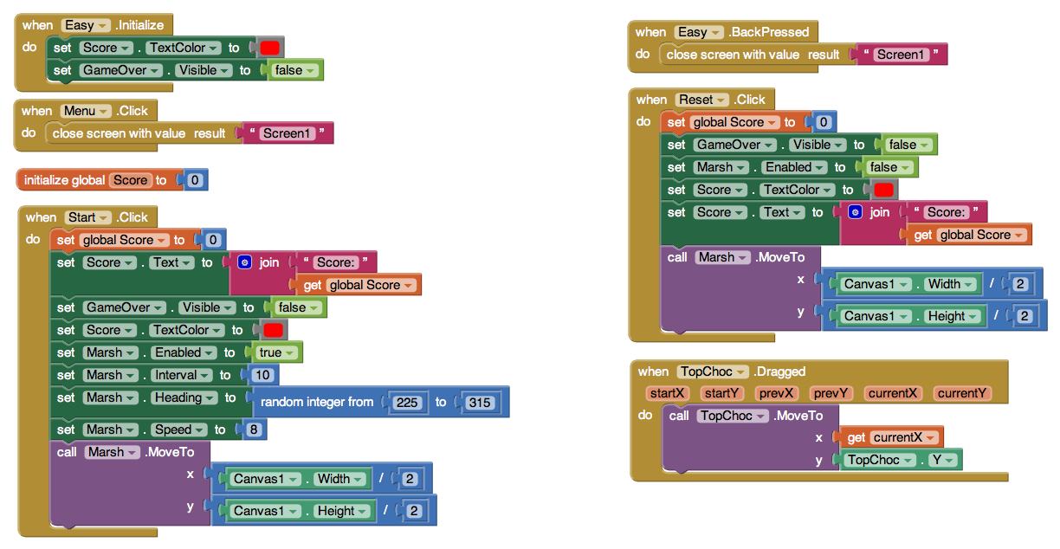

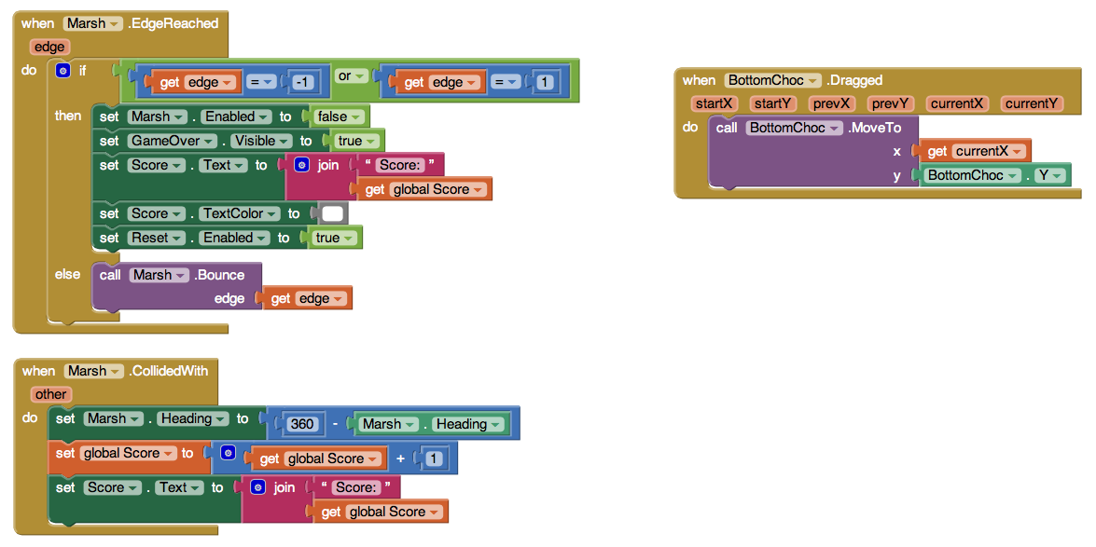

# Screen Medium Code:

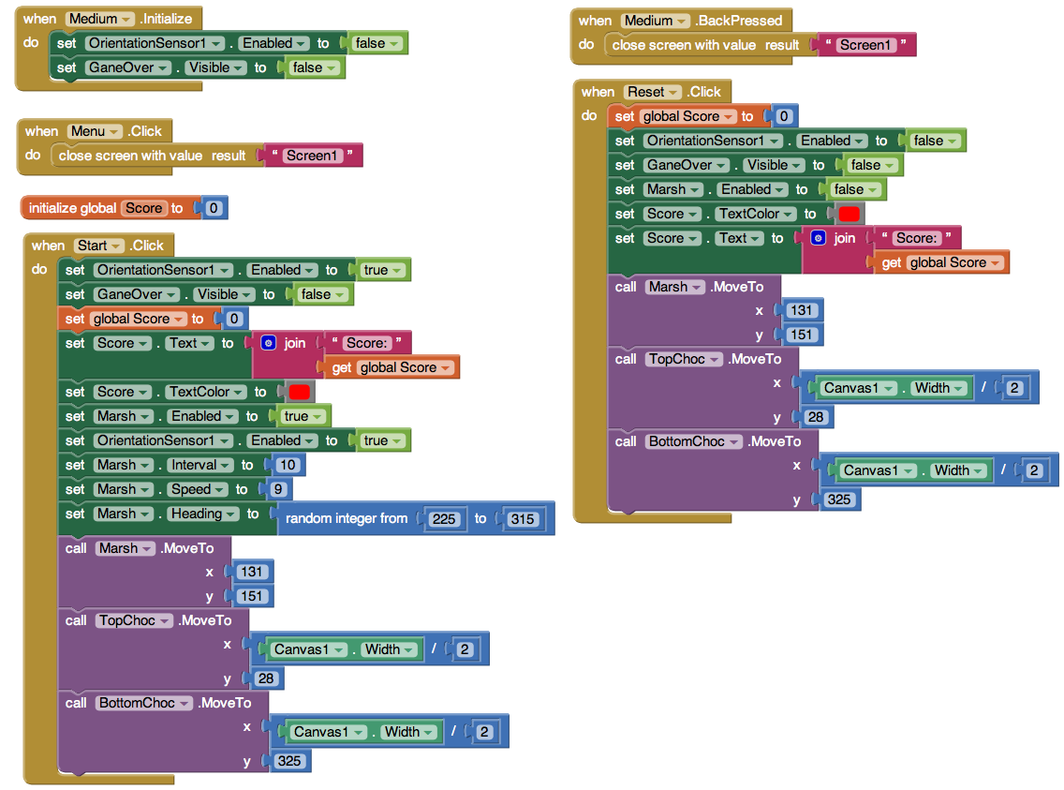

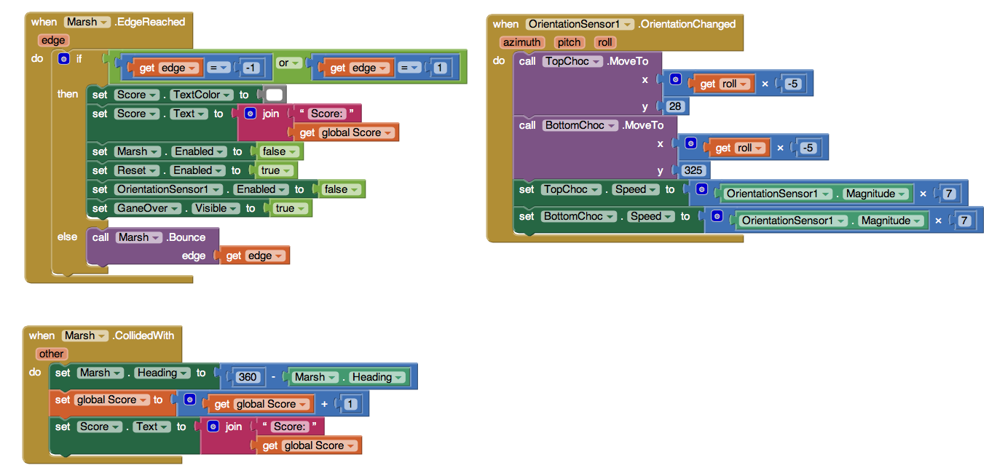

# Screen Hard Code:

